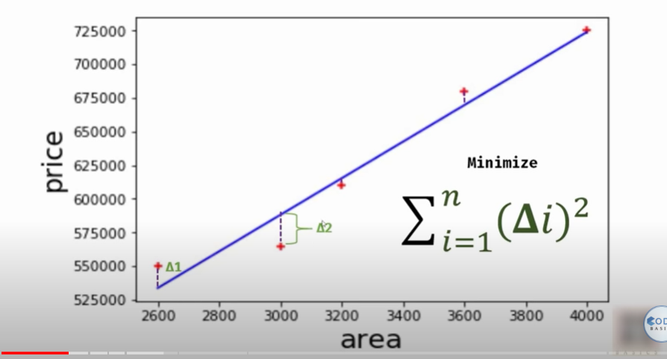

Simple linear regression line drawn based on min error